Skill Week-5 (GET & POST Methods)

GET API - Retrieve all students
@app.get("/students") def get_students():
with engine.connect() as connection: result = connection.execute( text("SELECT * FROM students")
) students = result.mappings().all()

return {
"message": "Students retrieved successfully",
"students": students
}

What is shown on Swagger for above code-
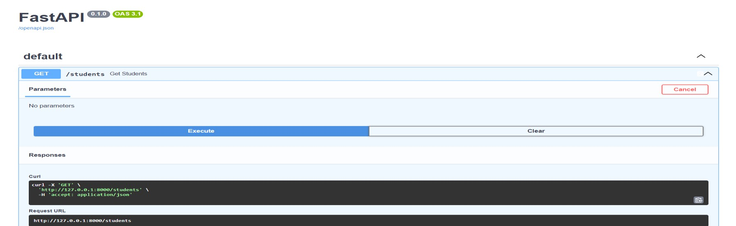
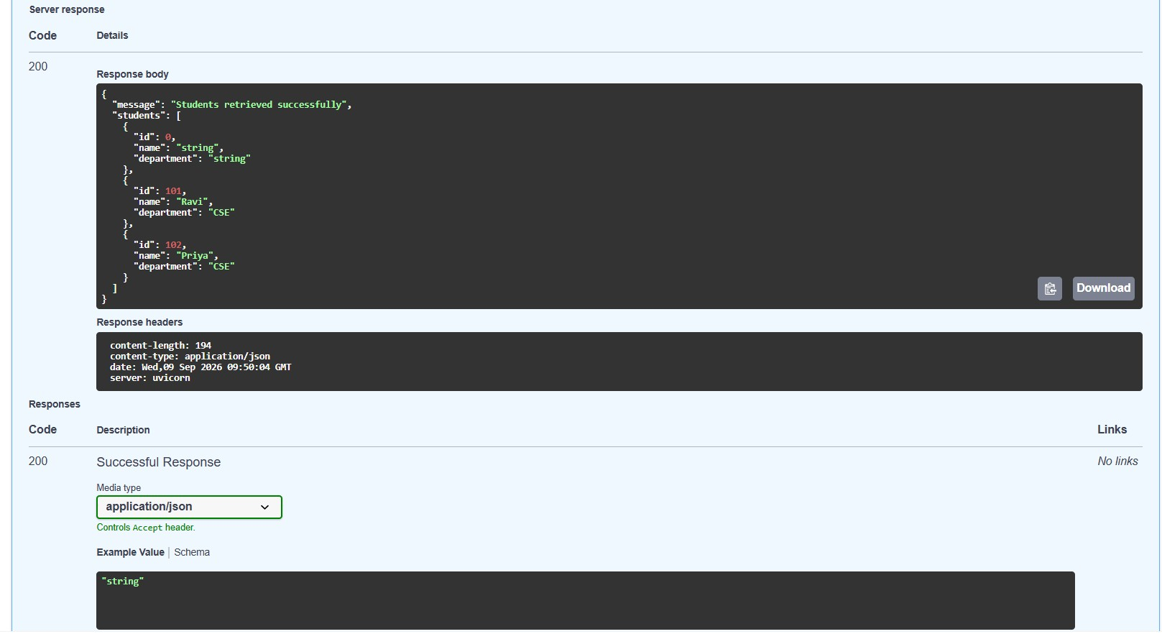

POST API - Add a new student

@app.post("/students") def create_student(student: Student):
with engine.begin() as connection:
connection.execute( text("""
INSERT INTO students (id, name, department)
VALUES (:id, :name, :department)
"""),
{
"id": student.id,
"name": student.name,
"department": student.department
}
)

What is shown for above POST code on Swagger-
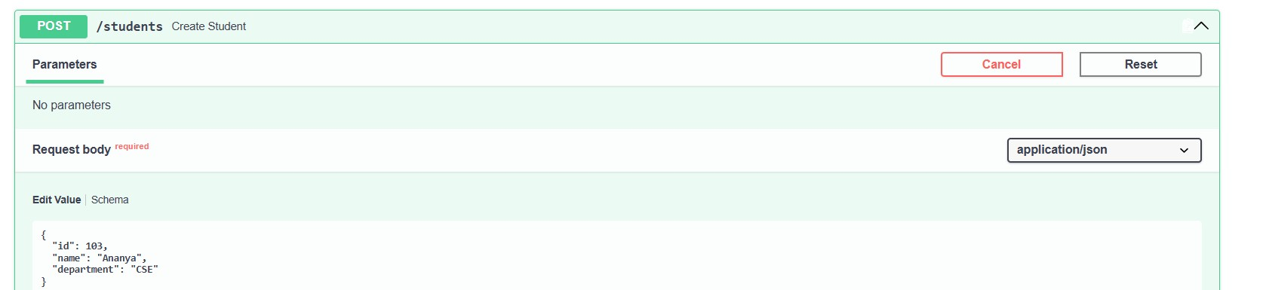

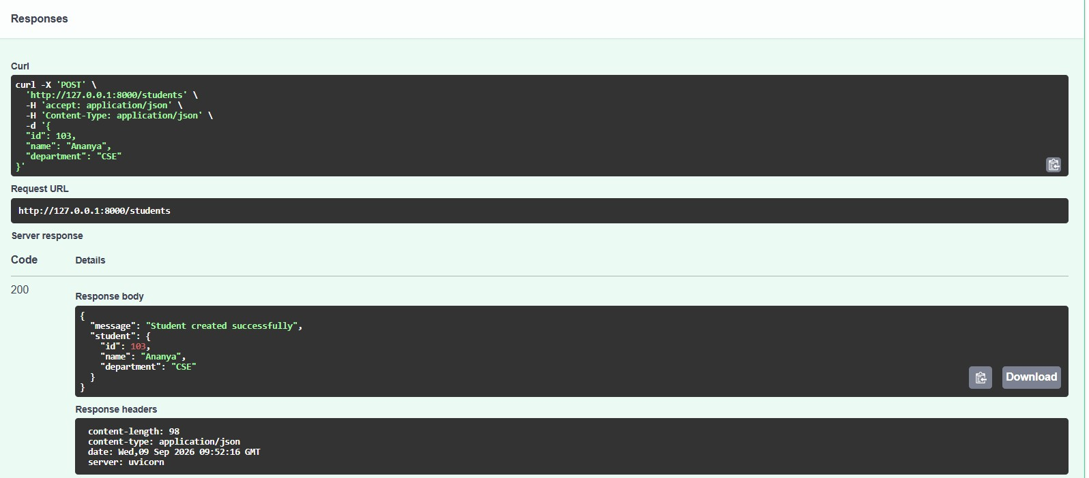
Before Posting Student Data:
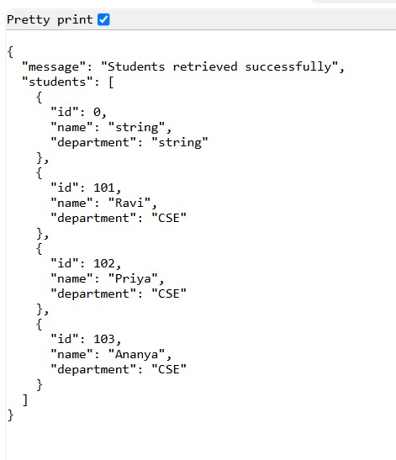
After posting student-104:
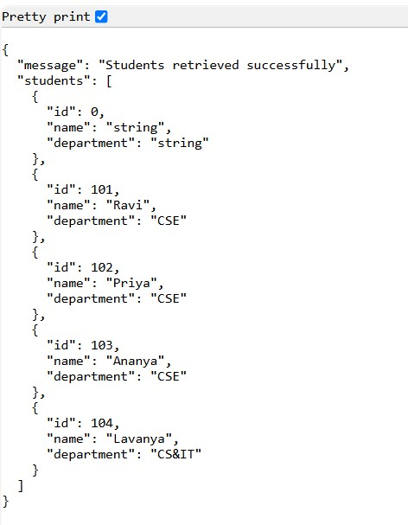

PUT - Update an existing student
@app.put("/students/{student_id}") def update_student(student_id: int, student: Student):
with engine.begin() as connection:
result = connection.execute( text("""
UPDATE students SET name = :name,
department = :department
WHERE id = :student_id
"""),
{
"student_id": student_id,
"name": student.name,
"department": student.department
}
) if result.rowcount == 0:
return {
"message": "Student not found"
}
return {
"message": "Student updated successfully",
"student": student
}

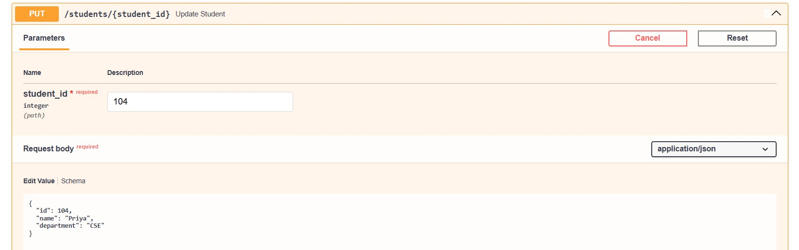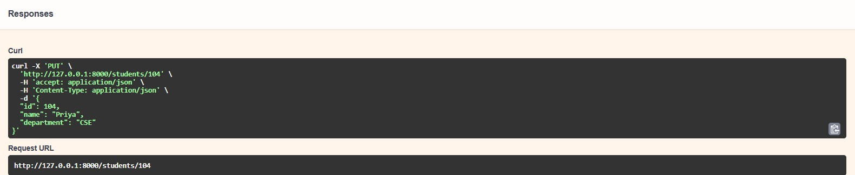
Output after editing using PUT:
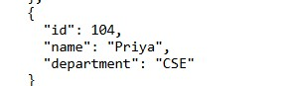

DELETE - Delete a student
@app.delete("/students/{student_id}") def delete_student(student_id: int):
with engine.begin() as connection:
result = connection.execute( text("""
DELETE FROM students
WHERE id = :student_id
"""),
{
"student_id": student_id
}
) if result.rowcount == 0:
return {
"message": "Student not found"
}
Output:
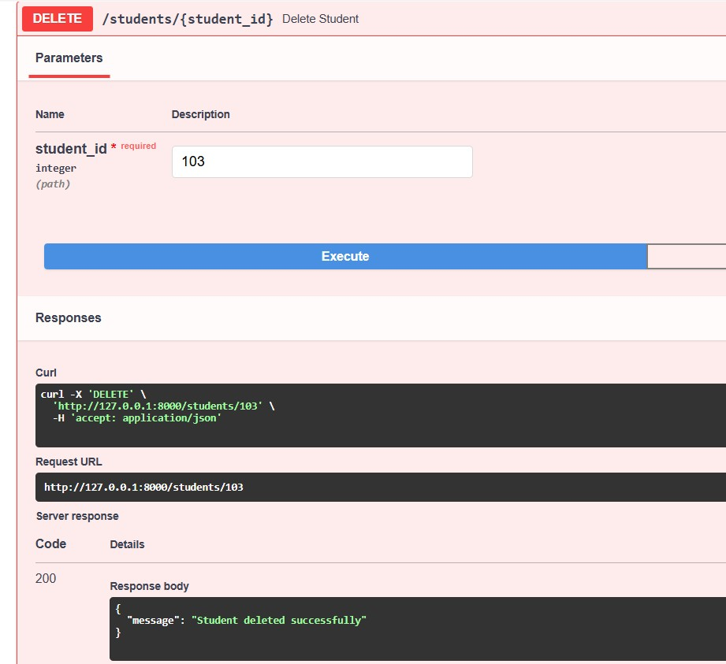
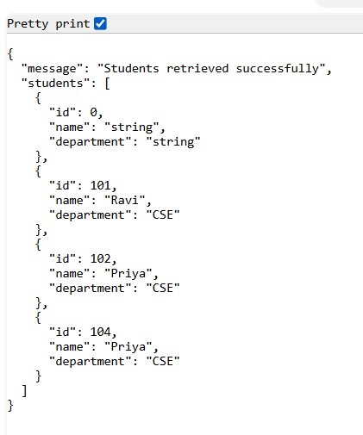

SQL Workbench Code:
CREATE DATABASE university;
USE university;

CREATE TABLE students ( id INT PRIMARY KEY, name VARCHAR(100), department VARCHAR(100)
);
SHOW DATABASES;
USE university;

INSERT INTO students (id, name, department)
VALUES
(101, 'Ravi', 'CSE'),
(102, 'Priya', 'CSE');

SHOW TABLES;
SELECT * FROM students;
Workbench Output:
